**Bond Challenge**

**Coding Question**

Write an interface for a data structure that can provide the moving average of the last N elements added, add elements to the structure and get access to the elements. Provide an efficient implementation of the interface for the data structure.

For your submission, please submit a PR to the main branch of this repository.

**Minimum Requirements**

1. Provide a separate interface (i.e. interface/trait) with documentation for the data structure
2. Provide an implementation for the interface
3. Provide any additional explanation about the interface and implementation in a README file.
4. Calculatiing the moving Average: (PYTHON)

*import numpy*

*def running_mean(x, N):*

*""" x == an array of data. N == number of samples per average """*

*cumsum = numpy.cumsum(numpy.insert(x, 0, 0))*

*return (cumsum[N:] - cumsum[:-N]) / float(N)*

val = [-30.45, -2.65, 56.61, 47.13, 47.95, 30.45, 2.65, -28.31, -47.13, -95.89]

print(running_mean(val, 3))

""" [ 7.83666667 33.69666667 50.56333333 41.84333333 27.01666667

1.59666667 -24.26333333 -57.11

2) We can create an RESTAPI which does the below activities.

submit both request URLs and curl statements.

process **GET**, **POST**, **PUT**, **PATCH** and **DELETE** requests.

a **POST**, **PUT**, **PATCH** and **DELETE** request can have a **body** parameter. It will be sent in a JSON object with the following format: {"input": ravg}.

Input is the value set and ravg is the value of running avg number.

consume **XML, JSON or plain text** formatted responses. This includes blog feeds as those feeds are formatted using XML.

3) We need to consider below points when we implement the API.

Supported data formats

Uniform Resource Identifiers

Endpoints

Versioning

Security & authentication

Scalability and flexibility

Monitoring and error handling

HTTP status codes

Testing, stability, and support

**Design Question**

A Pizza Restaurant chain “Pizza House” has more than 2000 stores across the country. Each store manages its own inventory of raw materials. Each store prepares pizzas, side dishes, etc. and sells them along with ready to eat products such as cookies, drinks, etc. The sale can happen by Point of Sale (POS) or Online. The online transactions would be flowing in real time whereas the transactions made by POS can be synced every 15 minutes in batches. They offer pick-up and deliveries by 3rd party providers.

At the head office of the restaurant chain, management is concerned with the logistics of ordering, stocking and selling products while maximizing profits as well as understanding their marketing & communications. Several promotional schemes such as temporary price reductions, ads in newspapers, displays etc., also keep rising. Considering the huge data volumes (hundreds of GB per month) and the variety of the data they have; management wants the architecture to be robust enough to handle the varying data loads.

Design a cloud data platform to process and deliver insights based on the above. Please provide a high level solution design for the architecture. Feel free to choose any cloud provider you want.

**Requirements**

1. Handle large write volume: Billions of write events per day.
2. Handle large read/query volume: Millions of merchants wish to gain insight into their business. Read/Query patterns are time-series related metrics.
3. Provide metrics to customers with at most one hour delay.
4. Run with minimum downtime.
5. Have the ability to reprocess historical data in case of bugs in the processing logic.

Architucture of the PIZZA HUT.

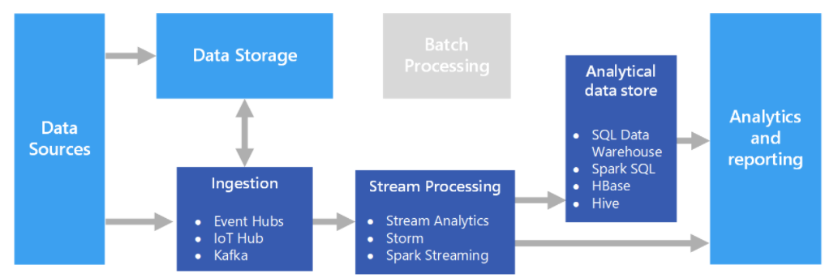

Here Data Sources means Pizza hut Stores which generate the data.

# We can achieve this by using with Apache Kafka on Azure. Azure HDInsight is a managed service with a cost-effective VM based [pricing model](https://azure.microsoft.com/en-us/pricing/details/hdinsight/) to provision and deploy Apache Kafka clusters on Azure. HDInsight ensures that brokers stay healthy while performing routine maintenance and patching with a 100 percent SLA on Kafka uptime.

# HDInsight Interactive Query to query data stored in Azure storage & Azure Data Lake Storage in super-fast manner.

# 

# We can use publish reports using Power BI reporting tool.

# Using above mentioned infrastructure we will have almost zero downtime.

1. Azure SQL Data Warehouse is a managed petabyte-scale service with controls to manage compute and storage independently using which we can access the historical data as well.